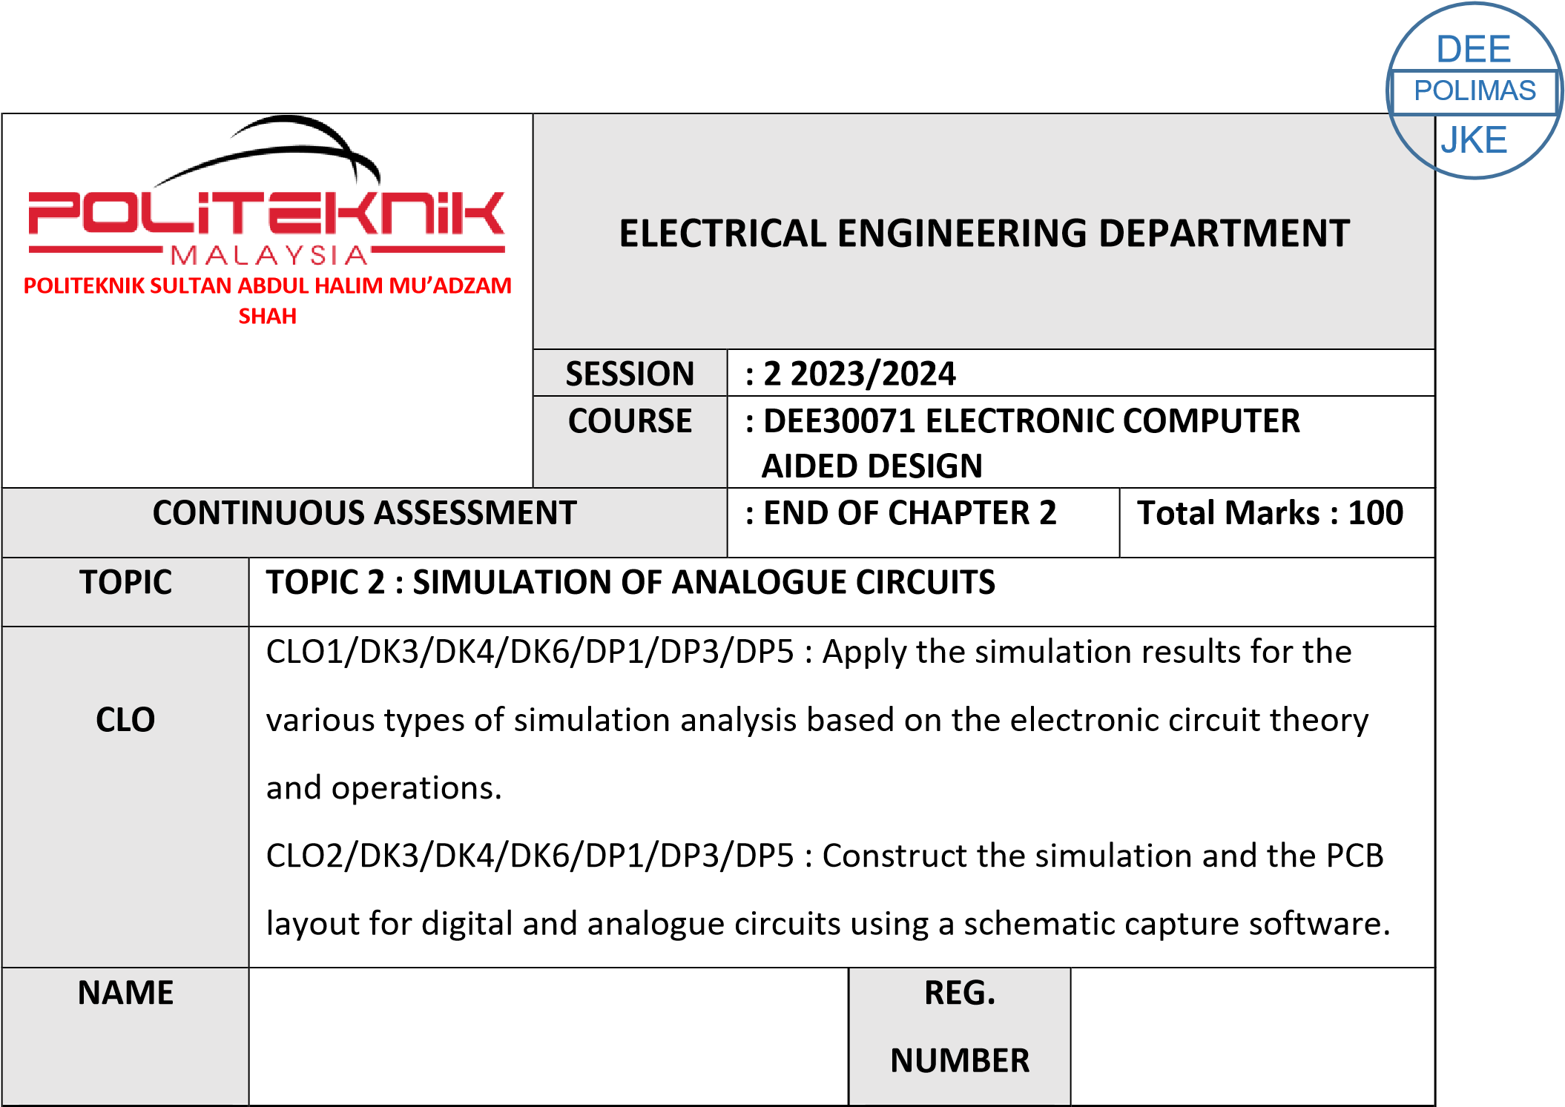

**03DET22F1043**

**CHONG KHENG CHEN**

|  |  |  |
| --- | --- | --- |
| CLO1 (C3, PLO1) | COGNITIVE ASSESSMENT  (20 %) |  |
| CLO2 (P4, PLO5) | PSYCHOMOTOR ASSESMENT  (80 %) |  |
|  | TOTAL MARKS  (100%) |  |

**\*Refer to Rubric**

|  |  |
| --- | --- |
| **1** | **LEARNING OUTCOMES (LO):**  1. Apply the simulation results for the various types of simulation analysis based on the electronic circuit theory and operations  (C3, PLO1) |
| **2** | **OBJECTIVE :** Apply transient analysis to simulate analogue circuits |
| **3** | **THEORY :** |
| **4** | **EQUIPMENT / TOOL / SOFTWARE :**   1. PC workstation 2. Related software |
| **5** | **PROCEDURE:**    **Question 1**  Students need to design this circuit given below (Figure 1) using transient analysis, then simulate the circuit. Answer the questions in Result Section.      **Figure 1**  (a) Set the attributes of the pulse source, V1, to produce the signal below. |

|  |  |
| --- | --- |
|  | i) From the Bar menu, select Analysis then setup. Check on the enable box for transient. ii) Click on the Transient Button. Set the specification as shown below Print Step = 1ms  Final time = 15ms  iii) Click the icon OK and simulate the circuit using the icon or menu bar  Analysis / Run.iv) From PROBE, Trace the output for Vin, Vout and Vclamp.        **Question 2**  1. Draw the RF amplifier circuit as shown below (using AC Analysis).      **Figure 2**     1. Simulate the circuit from 100Hz to 1MHz.      1. Produce the Bode Plot for the filter output. From the Bode plot, you are to determine (in dB) :      1. Maximum gain, A (max) in dB. |

|  |  |
| --- | --- |
|  | i. = …22054db………………………     1. cut-off frequency.      * 1. fc1 = …25013……………. fc2 =25068 …………………….      1. Bandwidth, BW      * 1. = ……127.028k…………………..      1. Print out the Bode plot.      1. From the curves obtained, determine the values of Vin and Vout at the input frequency 100Hz.      1. Calculate the voltage gain for the circuit by using the formula.     Av = Vout/Vin     1. Compare the value that you get at (h) with the output from Bode plot. |
| **6** | **Questions and Answers :**    1. (a) By using the voltage gain formula (for figure 2), get the value for Vout    Av = Vout / Vin    (b) Record the value for Vin, Vout and voltage gain in the table below :     |  |  | | --- | --- | | Circuit | Voltage Value | | Small Signal Amplifier | Vin = 1V  Vout = 4.162V  Av = 4.162V | | RF amplifier | Vin = 0.1V  Vout = 13.65V  Av = 136.5V | |

|  |  |
| --- | --- |
|  |  |

|  |  |  |  |  |  |  |
| --- | --- | --- | --- | --- | --- | --- |
|  |  | **PRACTICAL END OF CHAPTER 2** | | |  |  |
| Course Learning  Outcomes(CLO)/  Learning Domain Cluster (CLS) | Circuit | Skills / Aspects | Very Poor | Satisfactory | Very Good | Marks |
| 1 | 2 | 3 |
| CLO 1 : Apply the simulation results for the various types of simulation analysis based on the electronic circuit theory and operations.    CLO 2: Construct the simulation and the PCB layout for digital and analogue circuits using a schematic capture software.    CLS 1:  Knowledge &  Understanding    CLS3a :  Practical skill | 1 | **Construct circuit:** Student able to construct the circuit same as given. | Able to construct the  circuit with assistance. | Good to construct the circuit moderately with little assistance. | Excellent to construct the circuit effectively. | /3 |
| **Circuit Simulation:** Student able to simulate the circuit and observe the result correctly. | Able to simulate the circuit and observe the result correctly with assistance. | Good to simulate the circuit and observe the result correctly with little assistance. | Excellent to simulate the circuit and observe the result effectively. | /3 |
| **Results :** Student able to obtain the waveform and label the desired values in the circuit. | Able to obtain the waveform and label the desired values correctly with assistance | Good to obtain the waveform and label the desired values correctly with minimum assistance | Excellent to obtain waveform and label the desired values correctly and effectively. | /3 |
|  |  | | |  | /9 |
| 2 | **Construct circuit:** Student able to construct the circuit same as given. | Able to construct the  circuit with assistance. | Good to construct the circuit  moderately with little assistance. | Excellent to construct the circuit effectively. | /3 |
| **Circuit Simulation:** Student able to simulate the circuit and observe the result correctly. | Able to simulate the circuit and observe the result correctly with assistance. | Good to simulate the circuit and observe the result correctly with little assistance. | Excellent to simulate the circuit and observe the result effectively. | /3 |
| **Results :** Student able to obtain the waveform and label the desired values in the circuit. | Able to obtain the waveform and label the desired values correctly with assistance | Good to obtain the waveform and label the desired values correctly with minimum assistance | Excellent to obtain waveform and label the desired values correctly and effectively. | /3 |
|  |  | | |  | /9 |

# PRACTICAL SKILLS PSYCHOMOTOR ASSESMENT - (80%)

|  |  |  |  |  |  |
| --- | --- | --- | --- | --- | --- |
| **NO.** | **STUDENT’S NAME** | **FIGURE**  **1** | **FIGURE**  **2** | **Total:** | **80%** |
|  |
|  |  |  |  | **(18 marks)** |  |
| **1** | **CHONG KHENG CHEN** | /9 | /9 | /18 | /80 |

# PRACTICAL WORK COGNITIVE ASSESSMENT - (20%)

|  |  |  |  |  |
| --- | --- | --- | --- | --- |
| **MEASURE** | **QUESTION**  **1** | | **TOTAL** | **20**  **%** |
| (c, d and e) | a) | b) |
| /5 | /5 | /5 | /15 | /20 |

# TOTAL MARKS

|  |  |  |  |  |
| --- | --- | --- | --- | --- |
| **NO.** | **STUDENT’S NAME** | **COGNITIVE**  **ASSESSMENT**  **(20 %)** | **PSYCHOMOTOR**  **ASSESMENT**  **(80 %)** | **Total:** |
| **(100 %)** |
| **A** | **CHONG KHENG CHEN** | /20 | /80 | /100 |